AIM
To simulate Time Division Multiple Access (TDMA) communication for three different users transmitting in different time slots with varied payload sizes (100, 200, and 300 bits), and to verify whether the data recovered at the receiver matches the transmitted data, ensuring proper time-slot allocation and reliable communication.
SOFTWARE REQUIRED
MATLAB

THEORY
Time Division Multiple Access (TDMA) is a channel-sharing technique that divides time into slots, with each slot assigned to a specific user. Instead of transmitting simultaneously, users transmit one after another in their allocated time intervals.
This experiment demonstrates TDMA by assigning:
- Slot 1 → 100 bits
- Slot 2 → 200 bits
- Slot 3 → 300 bits
and verifying accurate recovery.
PROCEDURE
- Define the total number of users and time slots.
- Assign different payload sizes to different slots.
- Generate random binary data for each payload.
- Create a TDMA frame with enough slots to accommodate the largest slot number.
- Insert each user’s payload into its assigned slot position.
- At the receiver, extract data from the corresponding slot.
- Compare transmitted and recovered data to verify correctness.
- Display the result in a structured observation table.

PSEUDOCODE
Start

Define slot numbers and payload sizes:
Slot 1 → 100 bits
Slot 2 → 200 bits
Slot 3 → 300 bits

For each slot:
Generate random binary data of given payload size
Create TDMA frame with required number of slots
Insert data into the assigned slot using:
start_index = (slot_number - 1) * slot_size + 1
end_index = slot_number * slot_size
Extract the same slot at receiver
Compare transmitted and recovered data
Display recovery status

End

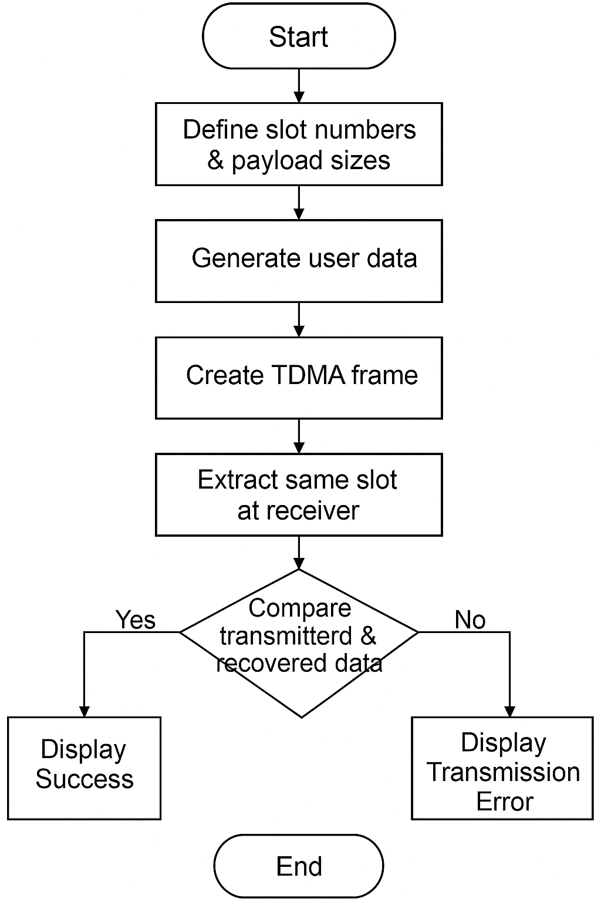
FLOW CHART
MATLAB Code – Experiment A
%% EXPERIMENT A – TDMA Slot 1 (100 bits)
clc; clear; close all;

payloadBits = 100;
slotLength = 100;

% Generate user data
user1_data = randi([0 1], 1, payloadBits);

% TDMA frame with 1 slot
TDMA_frame = zeros(1, slotLength);
TDMA_frame(1:slotLength) = user1_data;

% Receiver extracts slot 1
recovered = TDMA_frame(1:slotLength);

% Check recovery
result = "Yes";
if ~isequal(user1_data, recovered)
result = "No";
end

% Observation Table
fprintf("\nObservation Table – Experiment A\n");
fprintf("Slot\tUser\tPayload Bits\tRecovered?\n");
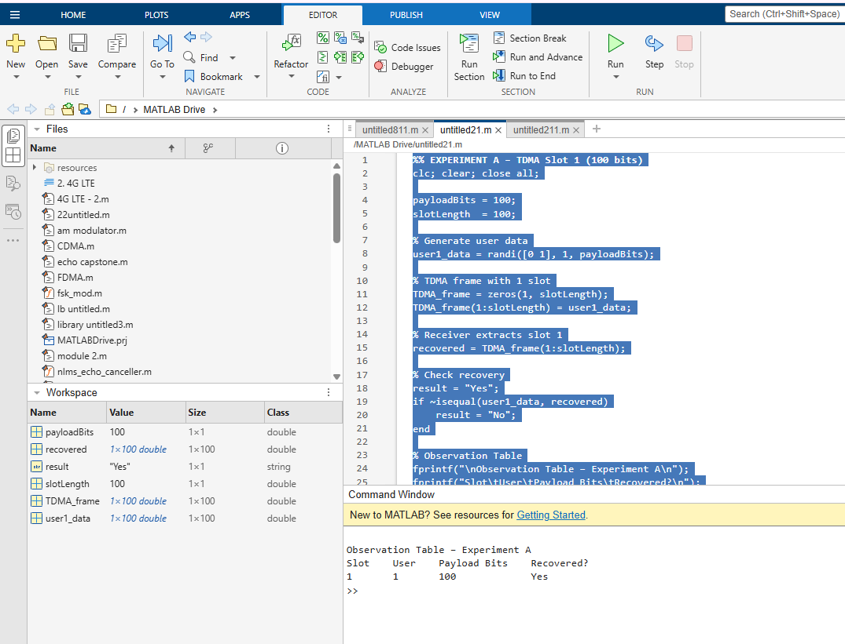
fprintf("1\t1\t%d\t\t%s\n", payloadBits, result);
Output
MATLAB Code – Experiment B
%% EXPERIMENT B – TDMA Slot 2 (200 bits)
clc; clear; close all;

payloadBits = 200;
slotLength = 200;

% Generate user data
user2_data = randi([0 1], 1, payloadBits);

% TDMA frame with 2 slots
TDMA_frame = zeros(1, 2*slotLength);
TDMA_frame(slotLength+1 : 2*slotLength) = user2_data;

% Receiver extracts slot 2
recovered = TDMA_frame(slotLength+1 : 2*slotLength);

% Check recovery
result = "Yes";
if ~isequal(user2_data, recovered)
result = "No";
end

% Observation Table
fprintf("\nObservation Table – Experiment B\n");
fprintf("Slot\tUser\tPayload Bits\tRecovered?\n");
fprintf("2\t2\t%d\t\t%s\n", payloadBits, result);

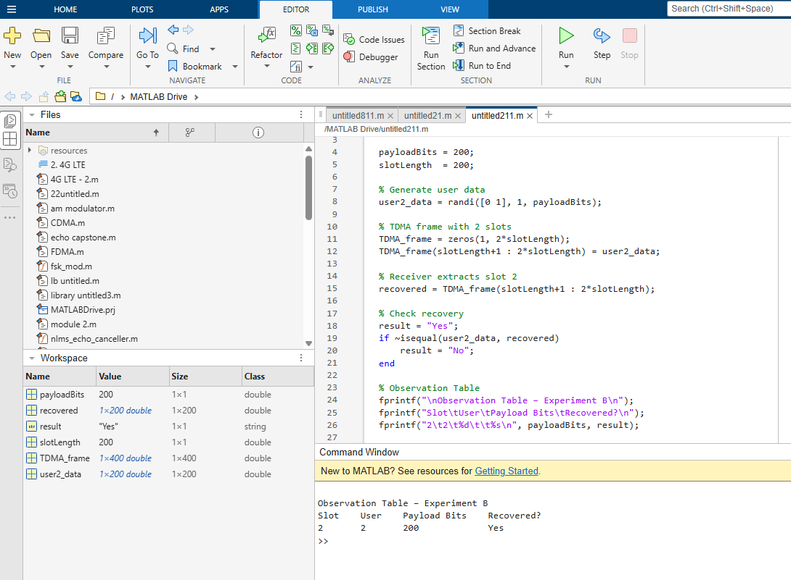
Output :

MATLAB Code – Experiment C
%% EXPERIMENT C – TDMA Slot 3 (300 bits)
clc; clear; close all;

payloadBits = 300;
slotLength = 300;

% Generate user data
user3_data = randi([0 1], 1, payloadBits);

% TDMA frame with 3 slots
TDMA_frame = zeros(1, 3*slotLength);
TDMA_frame(2*slotLength+1 : 3*slotLength) = user3_data;

% Receiver extracts slot 3
recovered = TDMA_frame(2*slotLength+1 : 3*slotLength);

% Check recovery
result = "Yes";
if ~isequal(user3_data, recovered)
result = "No";
end

% Observation Table
fprintf("\nObservation Table – Experiment C\n");
fprintf("Slot\tUser\tPayload Bits\tRecovered?\n");
fprintf("3\t3\t%d\t\t%s\n", payloadBits, result);
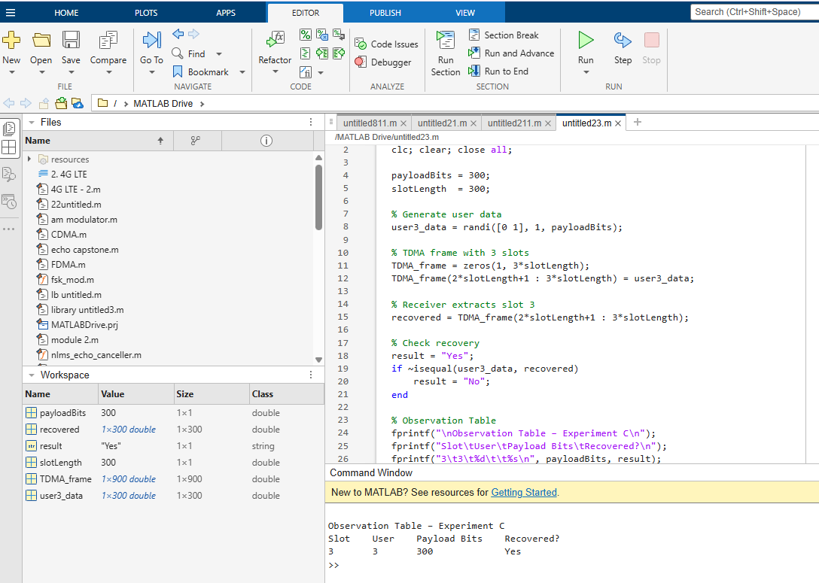
Output :
Observation
TABLE 2 — TDMA Observation
Frame No. | Slot No. | Assigned User | Payload Bits | Successfully Recovered?
1 | 1 | User 1 | 100 | Yes
1 | 2 | User 2 | 200 | Yes
1 | 3 | User 3 | 300 | Yes

Conclusion
The TDMA simulation demonstrated successful slot allocation and error-free recovery of 100-bit, 200-bit, and 300-bit payloads. The system proved reliable for multi-slot communication using TDMA.

